**Odd or Even**

#include<stdio.h>

int main()

{

int arr[50],n,e_c=0,o_c=0,i;

printf("Enter the number of elements: ");

scanf("%d",&n);

for(i=1;i<=n;i++)

scanf("%d",&arr[i]);

for(i=0;i<n;i++)

{

if(arr[i]%2==0)

e_c++;

else

o_c++;

}

printf("number of even number=%d\n",e_c);

printf("number of odd number=%d",o_c);

return 0;

}

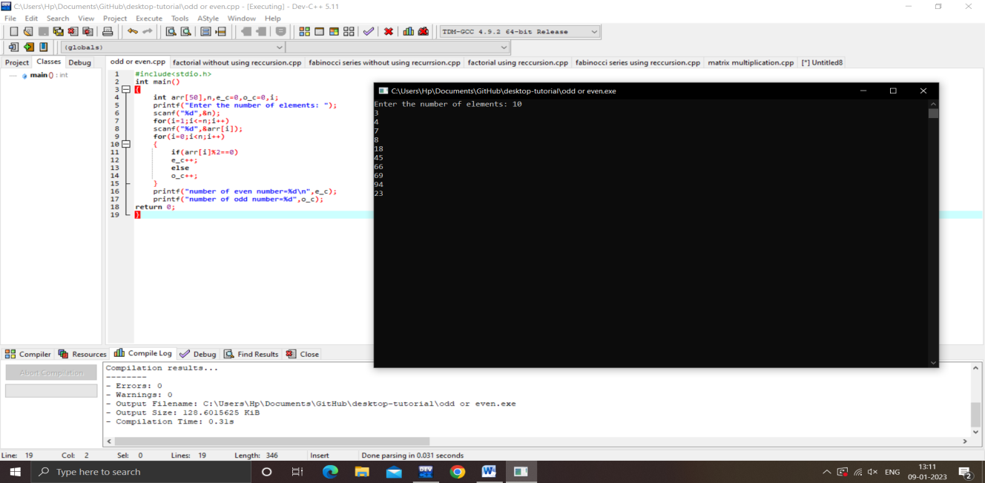

**Factorial without using recursion**

#include<stdio.h>

int main()

{

int n,i,fact=1;

printf("Enter any number: ");

scanf("%d",&n);

for(i=1;i<=n;i++)

{

fact=fact*i;

}

printf("Factorial of %d = %d",n,fact);

return 0;

}

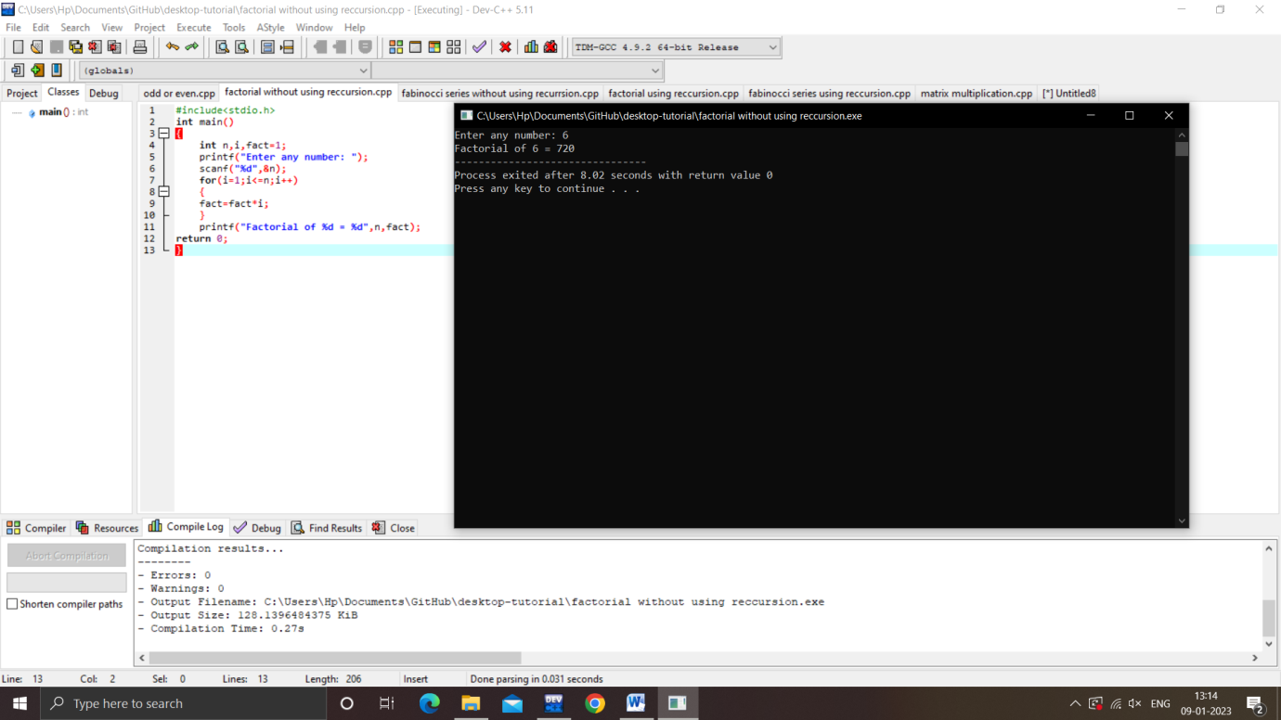

**Fabinocci series without using recursion**

#include<stdio.h>

int main()

{

int a=0,b=1,c,i,n;

printf("Enter a number: ");

scanf("%d",&n);

for(i=2;i<n;i++)

{

c=a+b;

printf("%d\n",c);

a=b;

b=c;

}

}

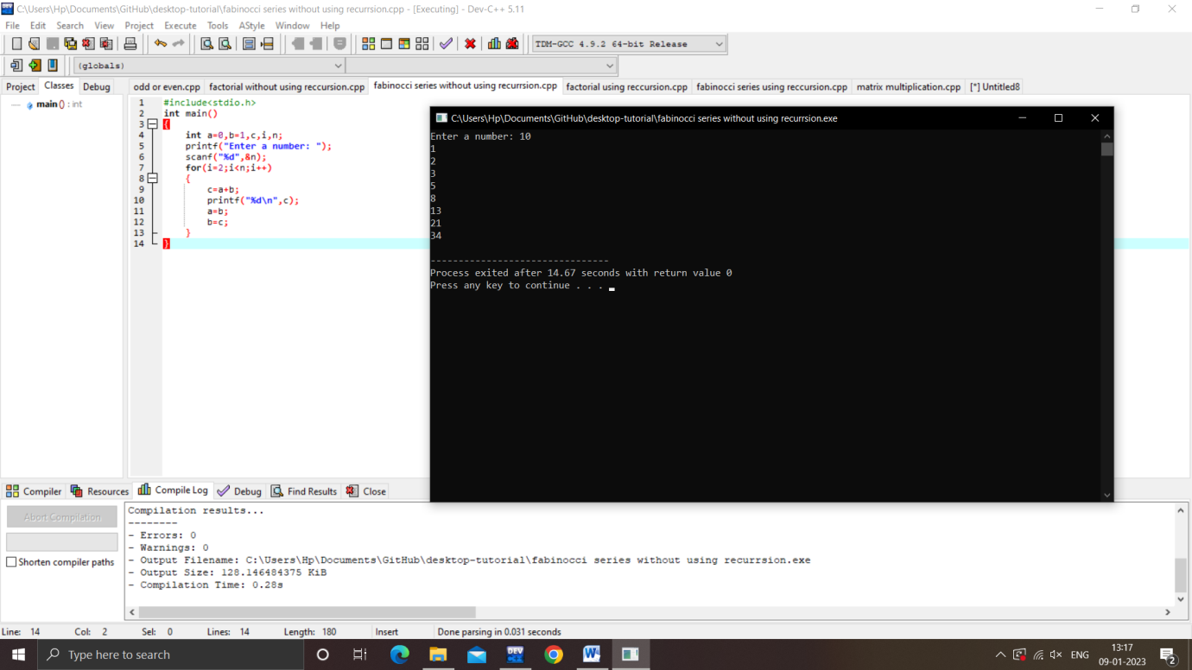

**Factorial using recursion**

#include<stdio.h>

int fact(int n)

{

if(n==1)

return 1;

else

return(n*fact(n-1));

}

int main()

{

int n,factorial;

printf("Enter any number: ");

scanf("%d",&n);

factorial=fact(n);

printf("Factorial of %d = %d",n,factorial);

return 0;

}

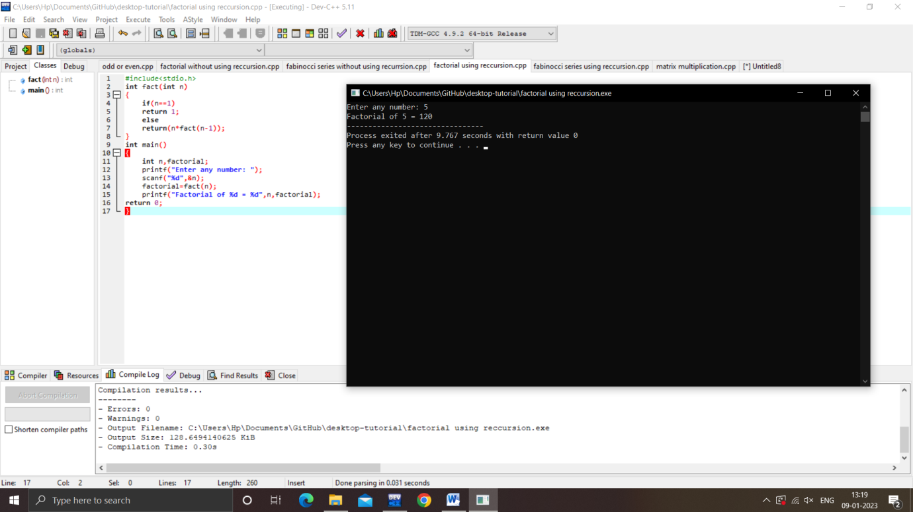

**Fabinocci series using recursion**

#include<stdio.h>

int f(int n)

{

if(n==0)

return 0;

else if(n==1)

return 1;

else

return(f(n-1)+f(n-2));

}

int main()

{

int a=0,b=1,c,i,n;

printf("Enter a number: ");

scanf("%d",&n);

for(i=2;i<n;i++)

{

c=a+b;

printf("%d\n",c);

a=b;

b=c;

}

}

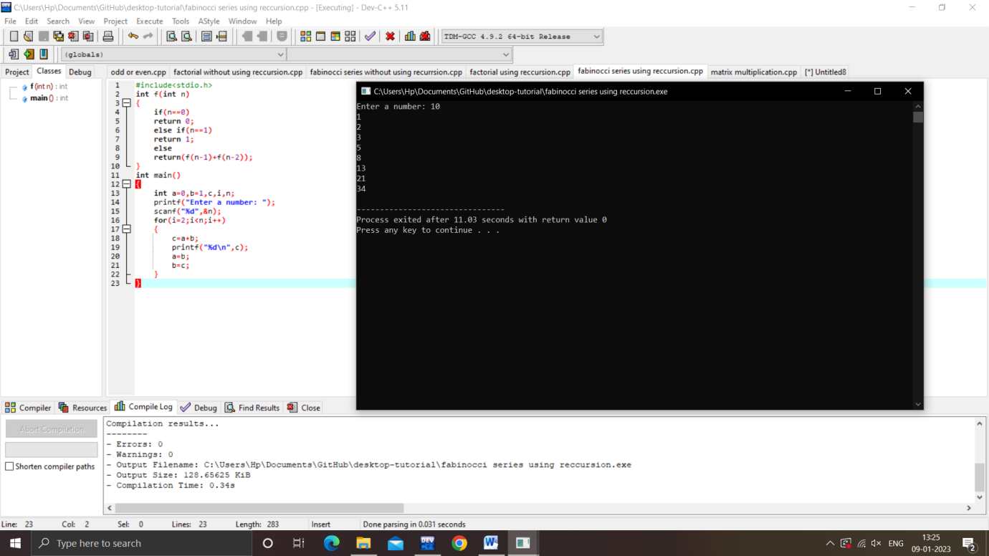

**Matrix multiplication**

#include<stdio.h>

int main()

{

int a[10][10],b[10][10],c[10][10],i,j,k,n,m,l;

printf("Enter the no.of rows and columns of A: ");

scanf("%d %d",&n,&m);

printf("Enter the no.of rows and columns of B: ");

scanf("%d %d",&m,&l);

printf("Enter the elements of A: ");

for(i=0;i<n;i++)

for(j=0;j<m;j++)

scanf("%d",&a[i][j]);

printf("Enter the elements of B: ");

for(j=0;j<m;j++)

for(k=0;k<l;k++)

scanf("%d",&b[j][k]);

for(i=0;i<n;i++)

for(k=0;k<l;k++)

{

c[i][k]=0;

for(j=0;j<m;j++)

{

c[i][k]+=a[i][j]*b[j][k];

}

}

for(i=0;i<n;i++)

{

for(k=0;k<l;k++)

{

printf("%d\t",c[i][k]);

}

printf("\n");

}

}

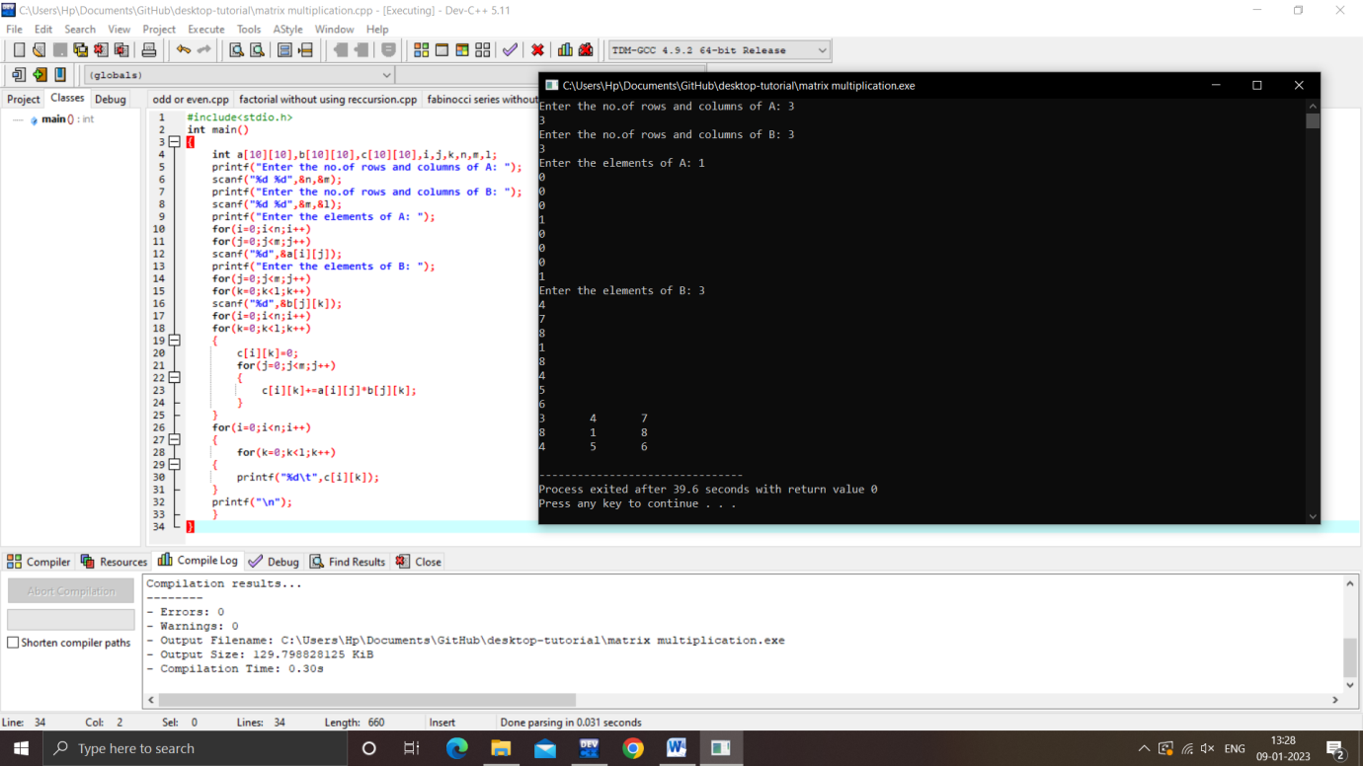

Liner search in array

#include<stdio.h>

int main()

{

int a[10],i,n,flag=0,key;

printf("Enter the size of array: ");

scanf("%d",&n);

printf("Enter the elements: ");

for(i=0;i<n;i++)

scanf("%d",&a[i]);

printf("Enter the key value: ");

scanf("%d",&key);

for(i=0;i<=n;i++)

{

if(a[i]==key)

{

flag=1;

break;

}

}

if(flag==1)

printf("Element is FOUND");

else

printf("Element is NOT FOUND");

}

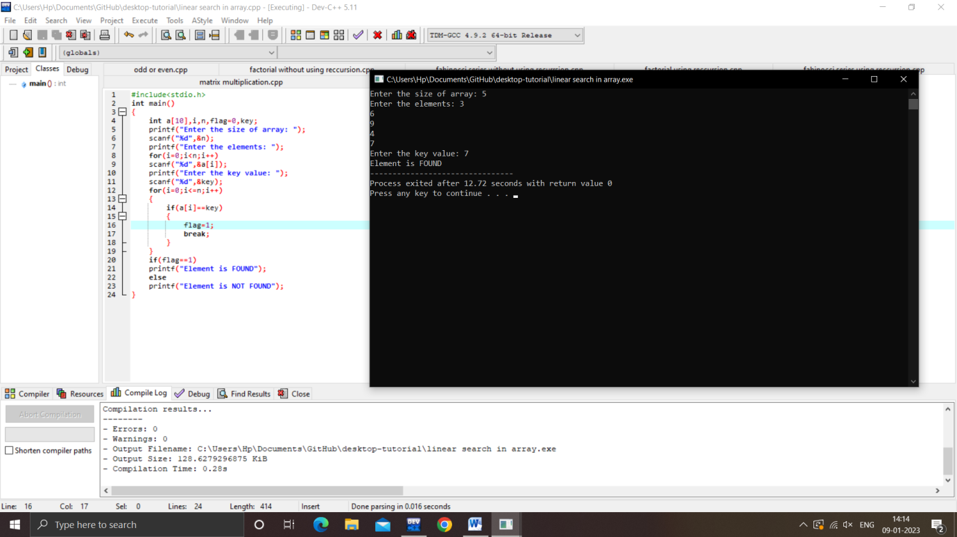

**Binary search in array**

#include<stdio.h>

int main()

{

int a[20],n,i,key,flag=0,f,l,m;

printf("Enter the size of array: ");

scanf("%d",&n);

printf("ENTER THE ELEMENTS IN ASCENDING ORDER : ");

for(i=0;i<n;i++)

scanf("%d",&a[i]);

printf("Enter the key value: ");

scanf("%d",&key);

f=0;

l=n-1;

while (f<=l)

{

m=(f+l)/2;

if(a[m]==key)

{

flag=1;

break;

}

else if(a[m]<key)

f=m+1;

else if(a[m]>key)

l=m-1;

}

if(flag==1)

printf("Element is FOUND");

else

printf("Element is NOT FOUND");

}

